Chapter-5: Implementation of this Project

# 5.1 Introduction

This is the most important phase to build a project. The project takes shape during the implementation phase. This phase involves the construction of the actual project based on analysis and design. Programmers are occupied with encoding, designers are involved in developing the graphic materials, contractors are building, the actual reorganization takes place. The implementation is the construction of the actual project.

**5.2 Tools and Technologies**

Tools and technologies are the most important part to develop a project. The tools denote the components that are used to create the environments for the programmers.

Technology is the collection of techniques, skills, methods, and processes used in the production of goods or services or in the accomplishment of objectives, such as scientific investigation. Technology can be the knowledge of techniques, processes, etc. or it can be embedded in machines, computers, devices, and factories, which can be operated by individuals without detailed knowledge of the workings of such things. The technology describes the way to code a particular project. In the implementation of this project the following tools and technology are used:

**Language**: HTML, PHP, CSS, MYSQL, BOOTSTRAP, JAVASCRIPT, JQUERY

**Framework**: LARAVEL [13]

**Environment**: Windows 8 and above.

**Tools:**

* Apache Server
* Sublime Text
* Visual Studio Code

**5.3 Graphical User Interface (GUI) for User**

Graphical User Interface (GUI) is the way to connect the user to this system. It is a very important element for a system. Good GUI always attracts more people to the system.

**5.3.1 Homepage**

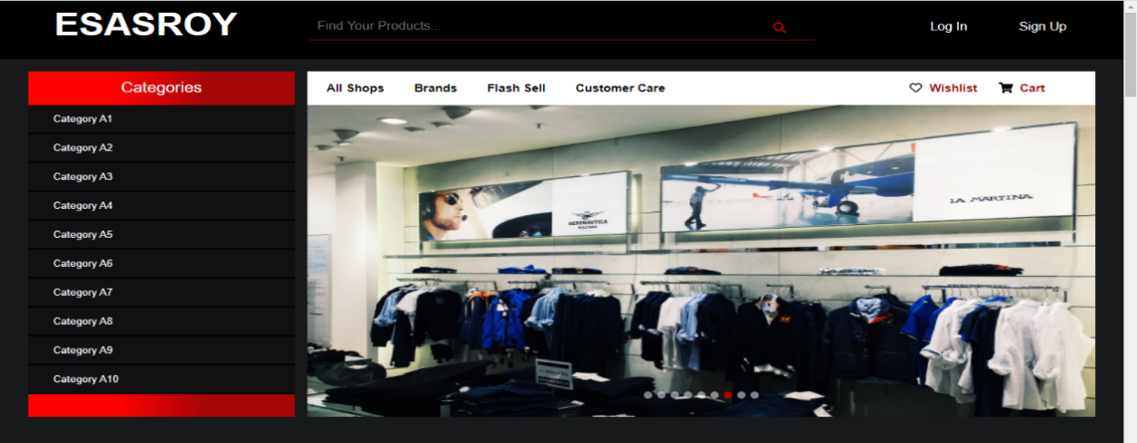

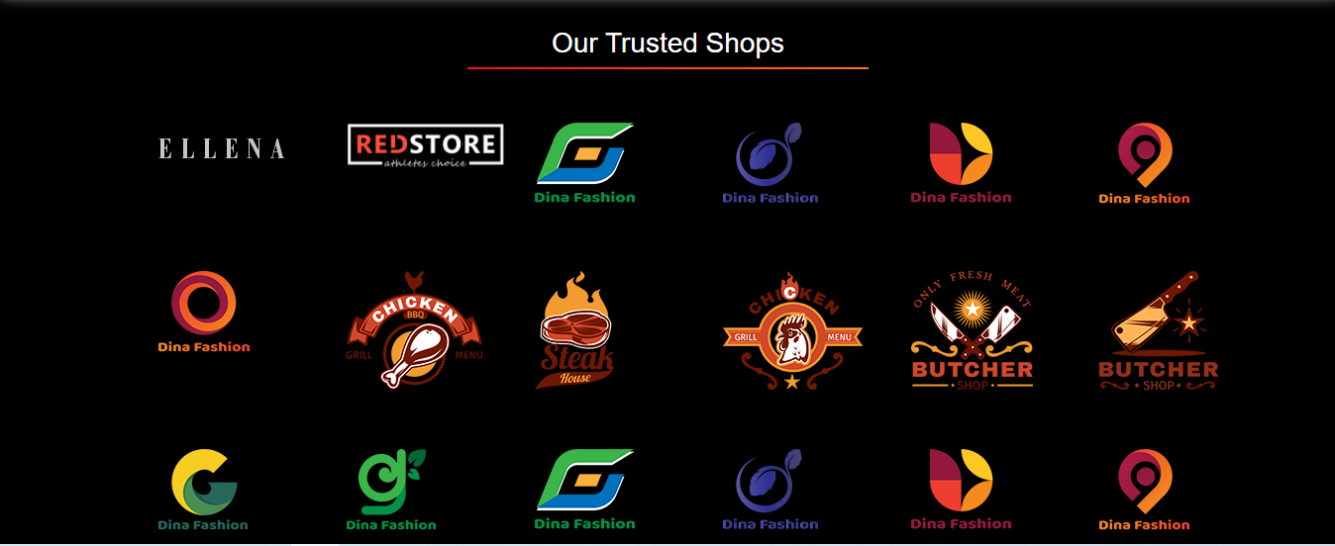

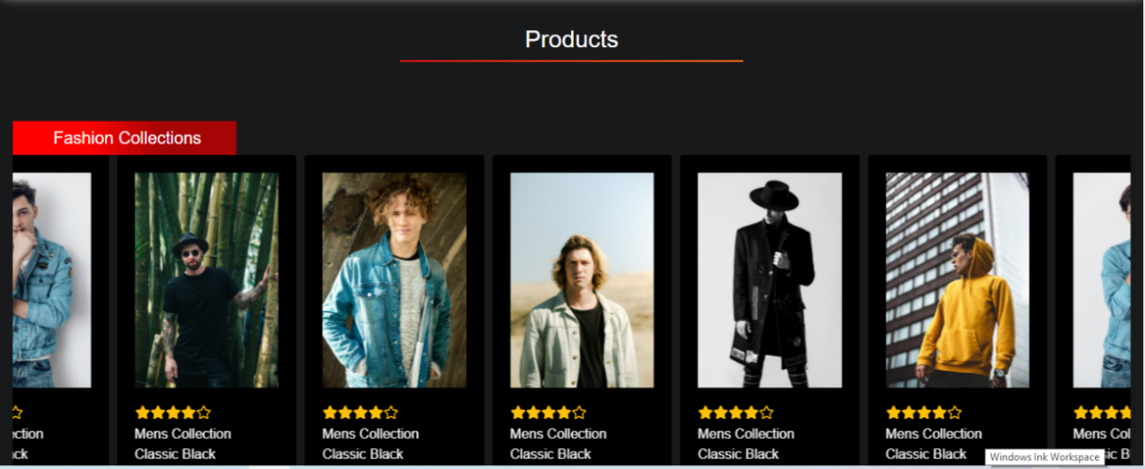

This is the Homepage of this system. Everyone can see this page when they will visit this system. It is a dynamic web-page. Where all data comes from Database, no static data used in this system. Users can see the product directly after visiting the system, User do not need to register to view a product from this system, but to order users just need to Sign up in the system.

**5.3.2 Product Specification**

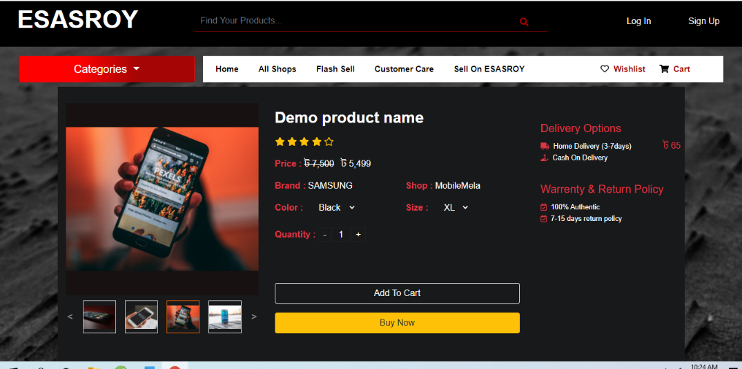

A single product specification is shown here. Here a customer can buy a product directly and also add a product to the cart and buy later. Delivery address and payment method are also shown here.

**5.3.3 Shopping Cart**

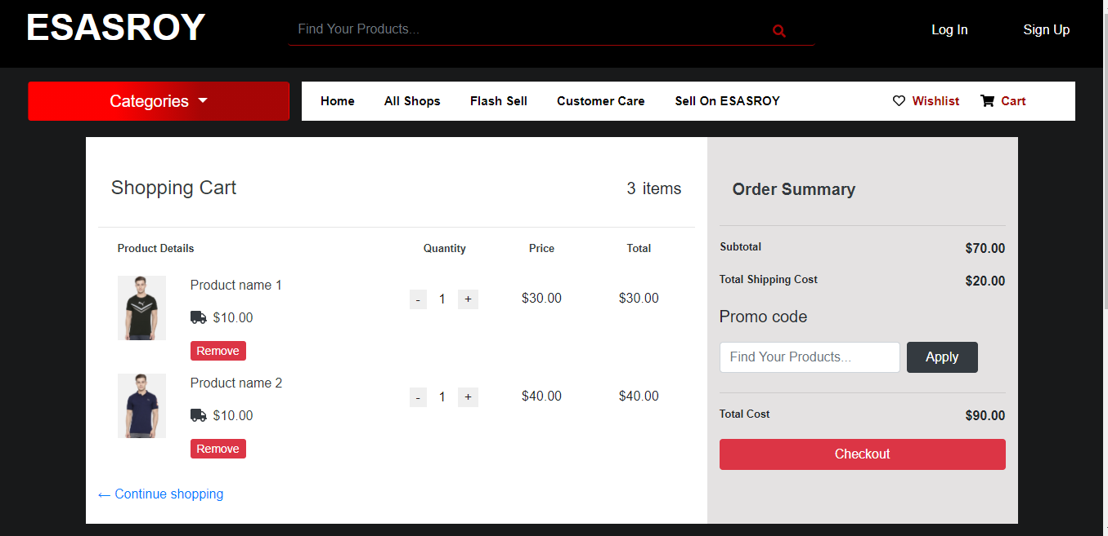

Shopping Cart is a web-page where products are store when a user wants to buy a product. It is mostly used to buy and handle when multiple products buy at a time. The Total amount (summation of product price and delivery charge) and quantity of product are shown here.

**5.3.4 Log-in and Sign-up Form**

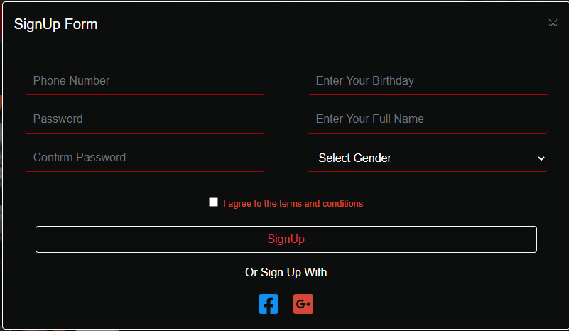

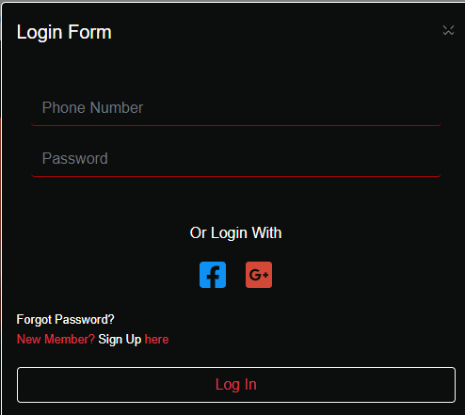

This is systems sign-up and log-in form. Everyone can join this system through this page. If anyone forgets his password, he can recover it through this page.

**5.4 Graphical User Interface (GUI) for Business Admin**

This section describes how a seller (Business Super Admin) can run his Business is this system. It is the GUI for Business Admins. The log-in page, admin dashboard, product stock, product specification pages are here.

**5.4.1 Business Super Admin Registration and Log-in Form**

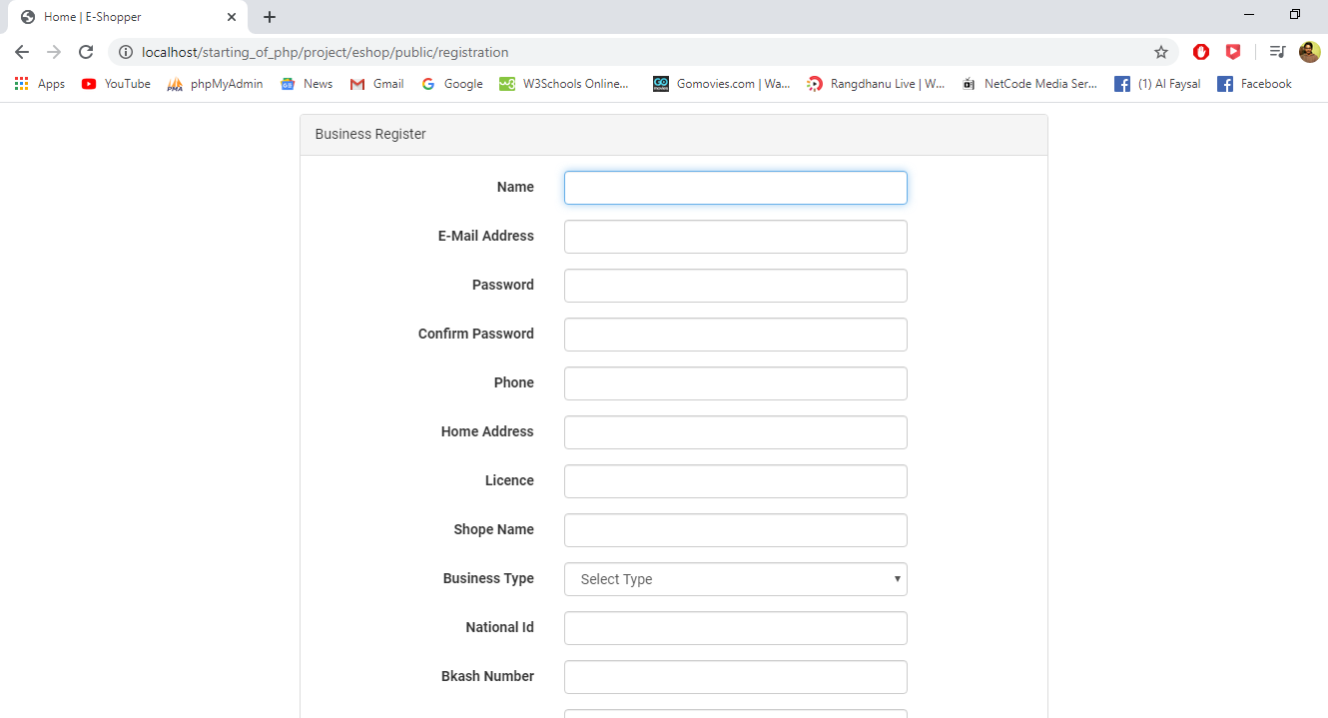

This is a registration form for Business Super Admin. When a business super admin wants to join with this project, they need to fill up this form and send a request through this form. After verification check, the System super admin can provide an account or not.

**5.4.2 Business Admin Dashboard and Product Specification Create**

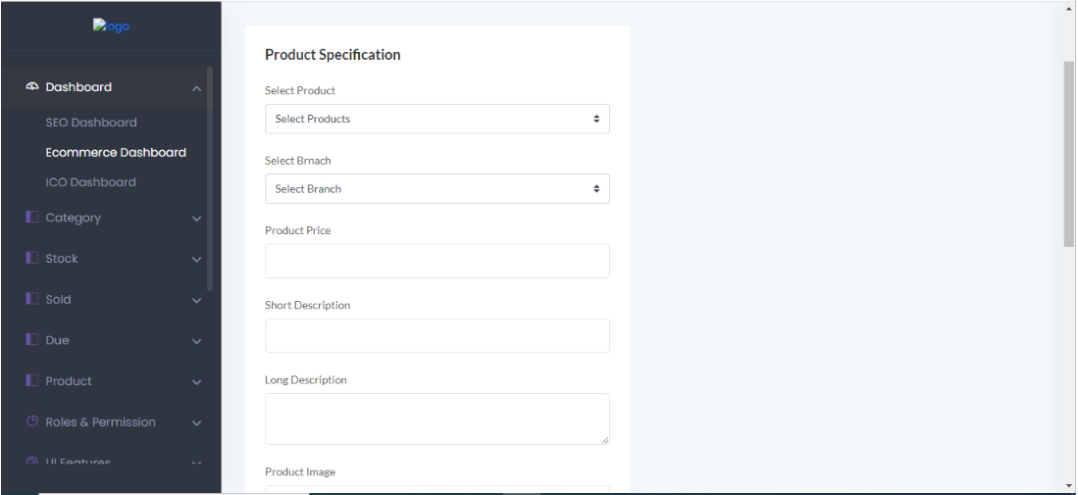

This is a Dashboard for Business Super Admin and Business Admin. Here Business super admin can upload product specification in this system. In product specification they need to upload price, short and long description, image, etc.

**5.4.3 Business Admin Dashboard and On-store Sale**

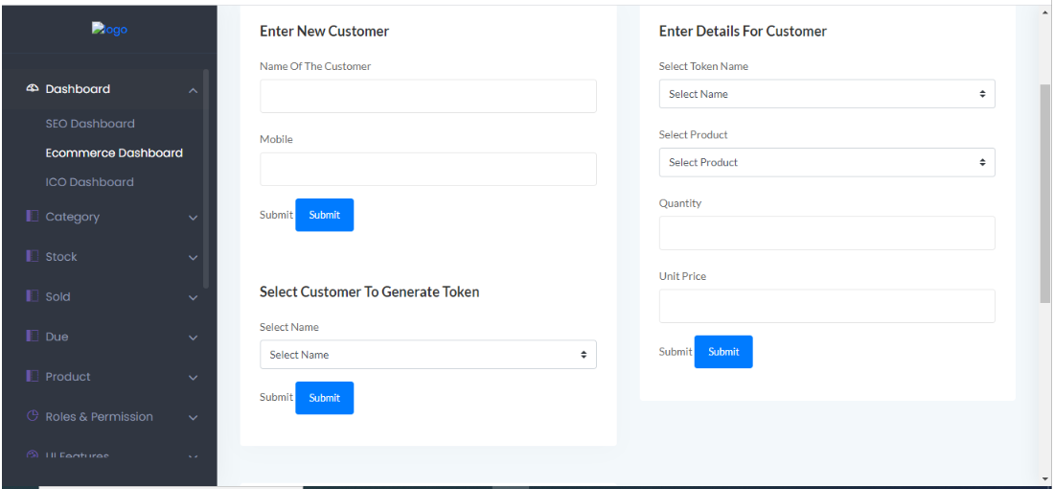

This is a part of the Dashboard for Business Super Admin and Business Admin. Business admin creates new customers and saves their information in it.

**5.4.4 Business Admin Dashboard and Report**

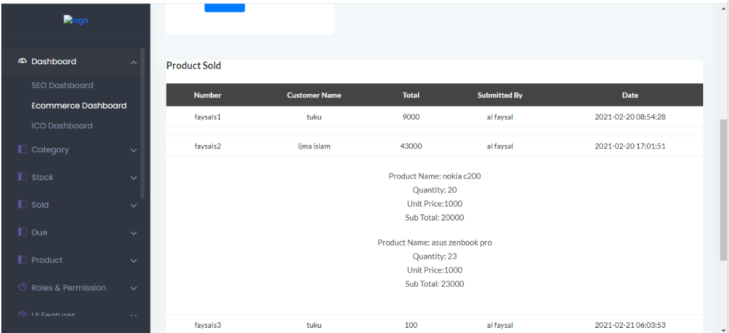

This is a part of the Dashboard for Business Super Admin and Business Admin. Here Business Super Admin and Business Admin can see the report about sales between any two dates.

**5.5 Graphical User Interface (GUI) for System Admin**

This section is how to a system admin run system. This is the GUI for System Admin has full authority over this system. They have access to any information in this system. They can see it, modify it needed.

**5.5.1 System Admin Dashboard**

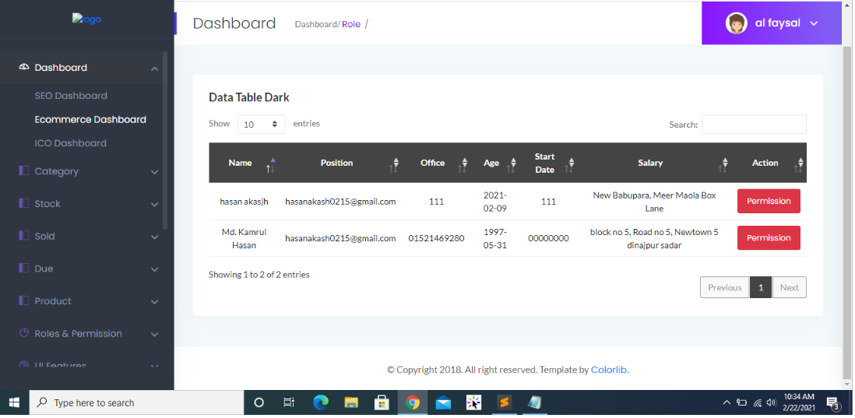

When a business super admin wants to join with this project, they need to fill up a form and send a request this request will be shown to admin super admin through this page After verification check, the System super admin can provide an account or not.

**5.6 Conclusion**

This system will perform as only this system required to run both type of business both traditional way and digital way (online platform). After implementing the system, some drawback is solved by this proposed system and some of feature has been added. Like,

* Marge individual singular platform in single platform.
* Direct product shipment.
* Sellers will get money instant after shipment.
* Provide business associate to run the business.